THE BATTLE OF THE BUNKS JUDGING IS
MONDAY-DECEMBER 23
HAVE YOU SIGNED UP ON THE SHEET IN YOUR UNIT? TO BE JUDGED YOU MUST BE ON THE LIST BY
TODAY FRIDAY- 20^{TH -} 12:30 PM.
FAMILY WINTER FAMILY EVENT Dec. 13, 2019
By Ms. Livesay and Mrs. Hust
Thank you to everyone that helped and came to the festivities. The night was a huge success again this year. The program was organized by Ms. Livesay, with very short notice. She had never seen one before but did an excellent job pulling it all together. I know her hard work was GREATLY appreciated.
She had the experienced help of Ms. Carsner, SFFC Camp Commander. They recruited eager elves to assist: Ms. Bustos, Ms. Haggart, Mr. Hanley, Ms. Watson, Ms. Robinson, Ms. Collins food-line servers: Ms. Vera, Ms. Dorgan, Mrs. Hust & last but not least our hard working super Superintendent Ms. Brown. Of course a big shout out to the AIC set up -Michael Little, Cody Dorman, Jason Johnson, Jason Melcado, Matthew Tilly, Morgan ???(sorry) & Jeramie Nelson and the elves on the morning cleanup crews.
Dinner was catered by Amalfi’s Restaurant & Mercato. We had pasta dishes, bread and salad with an array of dressings.
The servers would also like to apologize to Ms. Oleson and the morning kitchen crew. We didn’t know we were supposed to have a cleanup crew on hand when we ran out of paper plates! Lesson learned. The new planner will make sure we have enough plates & silverware next year from the caterer.
In between helping on the serve line Ms. Brown made a point of greeting and welcoming all of the men and their visitors.
The Multnomah County Librarians, Ms. A. Lewis-Early Childhood Services Manager--Every Child Initiative and Ms. J. McNamara-Early Literacy Program Specialist—A Book is a Bridge, were able to attend for the second year to bring a free book for every child. The children were able to choose their own book from a wide collection.
After the meal the children were given a big stocking with their names on it filled overflowing. Then, after the highlight of the evening of spending time with Dad, Santa came!! Santa took pictures with the children and he handed out gifts to all. This year every family also were given a Trader Joe’s Gingerbread House Kit to take home and make.
THE GENEROUS GIFT DONATIONS WERE FROM: The Gingerbread House Kits from Michael Allen of the Hollywood Trader Joe’s, Stockings and Presents from Talunaka Washington at DHS Toys for Tots.
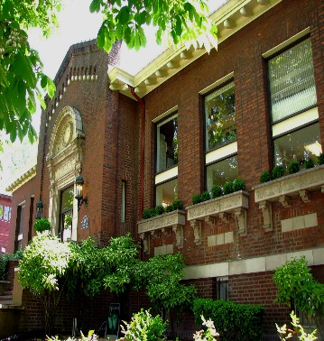
This Photo by Unknown Author is licensed under CC BY-SA
Multnomah County Library & Columbia River Correctional Institute: A Mutual Partnership by Ms. J. McNamara, Early Literacy Specialist
Multnomah County Library now offers two classes at CRCI: the Library Overview class, held on the third Wednesday of each month at 1pm, and A Book is a Bridge class on the fourth Friday of each month at 2pm.
The Library Overview Class shares information about all that is currently available in the nineteen branches of the library that are spread across Multnomah County. Libraries are constantly changing and evolving. They strive to keep up with newer and newer technology while maintaining a welcoming community space and one on one help when sharing resources and book recommendations to visitors.
For those who have been doing extended time, it may sound like an embarrassment of riches. With a library card, one is able to check out books, music, movies and a Discovery Pass that gives one access to theater, arts, and gardens. One author has said that possessing a library card rivals a credit card because it opens the door to a wealth of resources and world knowledge. But even if one does not have a library card they still have access to the library’s computer classes, tutoring, GED and citizenship classes, job search tools, research, information on legal services, shelters and more.
A Book is a Bridge is a class for parents, grandparents and relatives who have young children in their lives. This class shares information about the free resources and programs for families with young children at Multnomah County Library, and focuses on new research about the extraordinary development of their child’s brain and the explosion of language in the first years. The class is called A Book is a Bridge because sharing high quality children’s books can be a bridge to exploring the wonders of the world, as well as a bridge to understanding and talking about difficult topics with children. Children’s books also bring laughter and beauty and build a bond between parent and child.
Class participants will hear stories and then pick a book to save for their child. A children’s book author has said that, “If a child’s life is filled with picture books, read aloud from birth, that child will be better able to process the complexities in the world, read with deep understanding, and emotionally connect with themselves and with others. And the adults in their lives will grow right along with them.”

WINTER SEASON TRADITIONS & THEIR MEANING Wikipedia.com
Although these are some of the most well-known winter holidays celebrated in this country, Christmas Eve & Christmas Day celebrations. That doesn't mean they're the only holidays. Other popular winter holidays include:

Santa Lucia Day, an ancient Swedish festival during which blond-haired girls wear crowns of green leaves studded with lighted candles.
Winter Solstice, the first day of winter and the longest night of the year, is also celebrated with festivals, decorations and ancient ceremonies that honor nature.
Three Kings Day, also known as Epiphany, marks the day the three kings arrived to visit the newborn Christ child. This day is most commonly marked with festivities in Hispanic countries and cultures.
Bodhi Day by Buddhists. This recalls the date when Buddha attained enlightenment. (DEC-08).
Christmas by Christians. The ancient Christians took over Saturnalia, an ancient Roman Pagan seven day festival of Saturn which started on DEC-17 and used it to commemorate the birth of Yeshua of Nazareth (Jesus Christ). Internal evidence in the Bible
indicates that he was born in the Fall between 4 and 7 BCE.
The Day of the Return of the Wandering Goddess has also been observed by followers of Kemetic Orthodoxy, the religion of ancient Egypt, since about 4500 BCE This celebrates the return of the Goddess Hathor to her father Ra and the healing of their relationship. It is synchronized to the Winter Solstice.

KWANZAA: Principles and symbols
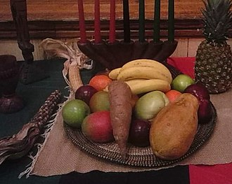
A display of Kwanzaa symbols with fruit and vegetables
Kwanzaa celebrates what its founder called the seven principles of Kwanzaa, or Nguzo Saba (originally Nguzu Saba – the seven principles of African Heritage), which Karenga said "is a communitarian African philosophy," consisting of what Karenga called "the best of African thought and practice in constant exchange with the world." They were developed in 1965, a year before Kwanzaa itself. These seven principles comprise Kawaida, a Swahili word meaning "common". Each of the seven days of Kwanzaa is dedicated to one of the following principles, as follows:^{[12]}
- Umoja (Unity): To strive for and to maintain unity in the family, community, nation, and race.
- Kujichagulia (Self-Determination): To define and name ourselves, as well as to create and speak for ourselves.
- Ujima (Collective Work and Responsibility): To build and maintain our community together and make our brothers' and sisters' problems our problems and to solve them together.
- Ujamaa (Cooperative Economics): To build and maintain our own stores, shops, and other businesses and to profit from them together.
- Nia (Purpose): To make our collective vocation the building and developing of our community in order to restore our people to their traditional greatness.
- Kuumba (Creativity): To do always as much as we can, in the way we can, in order to leave our community more beautiful and beneficial than we inherited it.
- Imani (Faith): To believe with all our hearts in our people, our parents, our teachers, our leaders, and the righteousness and victory of our struggle.
Kwanzaa celebratory symbols include a mat (Mkeka) on which other symbols are placed: a Kinara (candle holder), Mishumaa Saba (seven candles), mazao (crops), Mahindi (corn), a Kikombe cha Umoja (unity cup) for commemorating and giving shukrani (thanks) to African Ancestors, and Zawadi (gifts). Supplemental representations include a Nguzo Saba poster,^{[13]} the black, red, and green bendera (flag), and African books and artworks – all to represent values and concepts reflective of African culture and contribution to community building and reinforcement.^{[14]} Ears of corn represent the children celebrating and corn may be part of the holiday meal.^{[15]} ================================================================
Hanukkah (/ˈhɑːnəkə/ HAH-nə-kə; Hebrew: חֲנֻכָּה ḥanuká, Tiberian: ḥanuká, usually spelled חֲנוּכָּה‎, pronounced [χanuˈka] in Modern Hebrew, [ˈχanukə] or [ˈχanikə] in Yiddish; a transliteration also romanized as Chanukah or Ḥanukah) is a Jewish festival commemorating the rededication of the Second Temple in Jerusalem at the time of the Maccabean Revolt against the Seleucid Empire. It is also known as the Festival of Lights
(Hebrew: חַג הַאוּרִים, ḥag ha'urim). 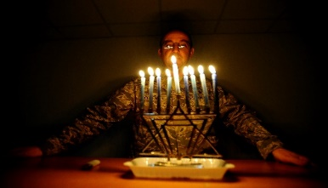 Hanukkah is observed for eight nights and days, starting on the 25th day of Kislev according to the Hebrew calendar, which may occur at any time from late November to late December in the Gregorian calendar. The festival is observed by lighting the candles of a candelabrum with nine branches, called a menorah (or hanukkiah). One branch is typically placed above or below the others and its candle is used to light the other eight candles. This unique candle is called the shamash (Hebrew: שַׁמָּשׁ‎, "attendant"). Each night, one additional candle is lit by the shamash until all eight candles are lit together on the final night of the festival.^{[2]} Other Hanukkah festivities include playing the game of dreidel and eating oil-based foods, such as latkes and sufganiyot, and dairy foods. Since the 1970s, the worldwide Chabad Hasidic movement has initiated public menorah lightings in open public places in many countries.^{[3]}

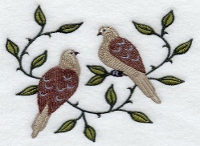 The Twelve Days of Christmas, also known as Twelvetide, is a festive Christian season celebrating the Nativity of Jesus. In most Western ecclesiastical traditions, "Christmas Day" is considered the "First Day of Christmas" and the Twelve Days are 25 December – 5 January, inclusive.^{[1]} For many Christian denominations—for example, the Anglican Communion and Lutheran Church—the Twelve Days are identical to Christmastide,^{[2][3][4]} but for others, e.g., the Roman Catholic Church, Christmastide lasts longer than the Twelve Days of Christmas.^{[5]}
This Photo by Unknown Author is licensed under CC BY-NC-ND

Western Christianity
Within the Twelve Days of Christmas, there are celebrations both secular and religious.
Christmas Day, if it is considered to be part of the Twelve Days of Christmas and not as the day preceding the Twelve Days,^{[2]} is celebrated by Christians as the liturgical feast of the Nativity of the Lord. It is a public holiday in many nations, including some where the majority of the population is not Christian. On this see the articles on Christmas and Christmas traditions.
26 December is "St. Stephen's Day", a feast day in the Western Church. In Great Britain and its former colonies, it is also the secular holiday of Boxing Day. In some parts of Ireland it is denominated "Wren Day".
New Year's Eve on 31 December is the feast of Pope St. Sylvester I and is known also as "Silvester". The transition that evening to the new year is an occasion for secular festivities in many nations, and in several languages is known as "St. Sylvester Night" ("Notte di San Silvestro" in Italian, "Silvesternacht" in German, "Réveillon de la Saint-Sylvestre" in French, and "סילבסטר" in Hebrew).
New Year's Day on 1 January is an occasion for further secular festivities or for rest from the celebrations of the night before. In the Roman Rite of the Roman Catholic Church, it is the Solemnity of Mary, Mother of God, liturgically celebrated on the Octave Day of Christmas. It has also been celebrated, and still is in some denominations, as the Feast of the Circumcision of Christ, because according to Jewish tradition He would have been circumcised on the eighth day after His Birth, inclusively counting the first day and last day. This day, or some day proximate to it, is also celebrated by the Roman Catholics as World Day of Peace.^{[16]}
In many nations, e. g., the United States, the Solemnity of Epiphany is transferred to the first Sunday after 1 January, which can occur as early as 2 January. That solemnity, then, together with customary observances associated with it, usually occur within the Twelve Days of Christmas, even if these are considered to end on 5 January rather than 6 January.
Other Roman Catholic liturgical feasts on the General Roman Calendar that occur within the Octave of Christmas and therefore also within the Twelve Days of Christmas are the Feast of St. Stephen, Proto-Martyr on 26 December; Feast of St. John, Apostle and Evangelist on 27 December; the Feast of the Holy Innocents on 28 December; Memorial of St. Thomas Becket, Bishop and Martyr on 29 December; and the Feast of the Holy Family of Jesus, Mary, and Joseph on the Sunday within the Octave of Christmas or, if there is no such Sunday, (cont.) on 30 December. Outside the Octave, but within the Twelve Days of Christmas, there are the feast of Sts. Basil the Great and Gregory of Nazianzus on 2 January and the Memorial of the Holy Name of Jesus on 3 January.

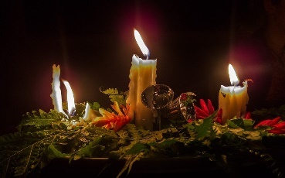
Pagan Mōdraniht or Modranicht (Old English "Night of the Mothers" or "Mothers' Night") was an event held at what is now Christmas Eve by the Anglo-Saxon Pagans. The event is attested by the medieval English historian Bede in his 8th-century Latin work De temporum ratione. It has been suggested that sacrifices may have occurred during this event. Scholars have proposed connections between the Anglo-Saxon Mōdraniht and events attested among other Germanic peoples (specifically those involving the dísir, collective female ancestral beings, and Yule) and the Germanic Matres and Matronae, female beings attested by way of altar and votive inscriptions, nearly always appearing in trios.

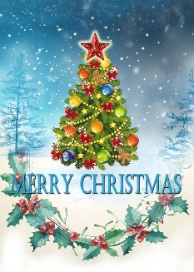 Legal Library News from Mrs. Hust --- Rumors are Semi-True
Yes, it’s true Mrs. Hust will be retiring on December 31st…….But she is planning on sticking around until May 1st, 2020. Hiring for the position has not taken place and it is not known “who will be replacing her.” Watch for any new announcements in the Currents. Until then please don’t ask.
LIBRARY IS CLOSED-HOLIDAY 24-25 & 30-JAN 2, 2020--SEE YOU IN THE NEW YEAR.


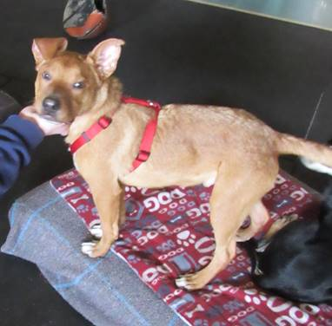 CRCI 
has welcomed 2 new dogs into the Second Chance Program.
Thor & Loki are both mixes and arrived Wednesday Dec.18th. Both are approximately 5 – 6 months old.
You will notice that both dogs are currently sporting Red bandanas. This means that there is no staff/inmate interaction with the dogs now. They will not be placed into green bandanas until after the year. But, until then, hugs and pets will have to wait.
Also, please do not offer any sort of “human” food to the dogs. Dog treats are acceptable, human food is not. We are trying to monitor their food intake and your help is greatly appreciated.


Rocks on The Lake Baikal Boredpanda.com
Rocks on the lake Baikal get heated from the sunlight every now and then and melt the ice beneath. After the sun is gone, the ice turns solid again thus creating a small stand for the rock above called the Baikal Dzen.

